# Ideation Phase

**Brainstorm & Idea Prioritization**

|  |  |
| --- | --- |
| Date | 01November 2022 |
| Team ID | PNT2022TMID43856 |
| Project Name | Emerging methods for early detection of forest fires |
| Maximum Marks | 4Marks |

# Step-1:Problem statement

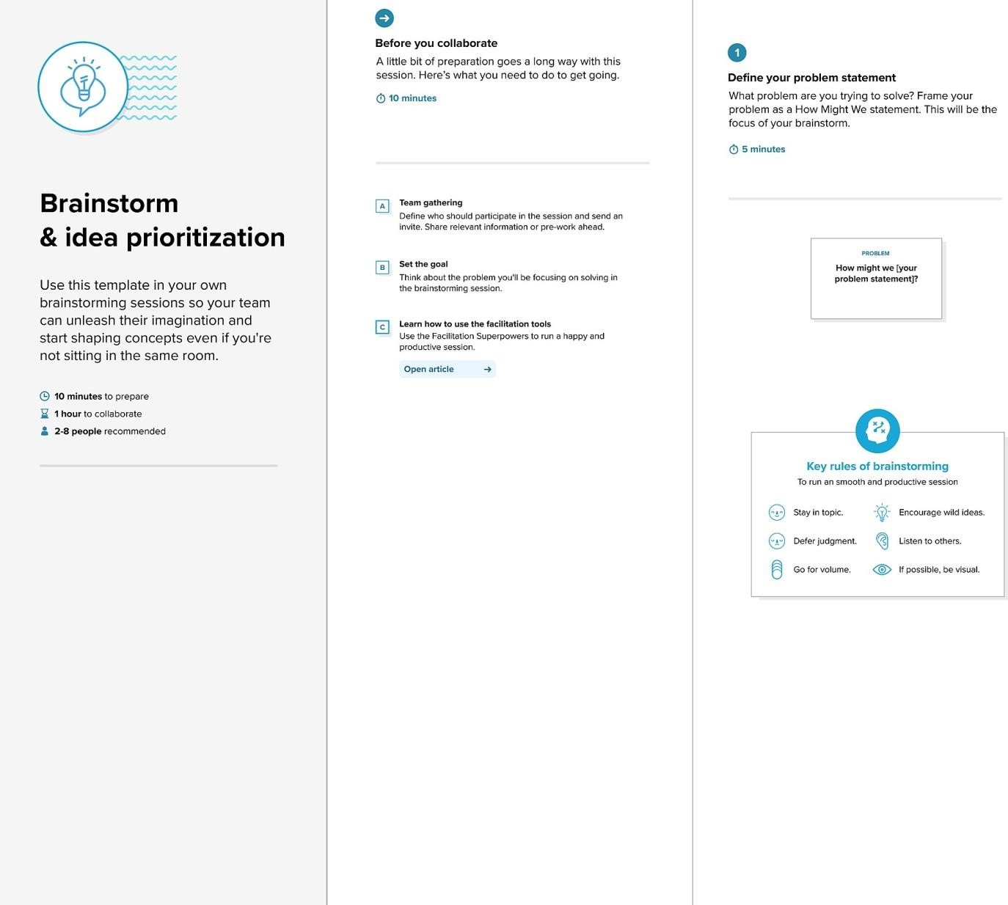

# Step-2: Brainstorm,Idea,Listing and Grouping

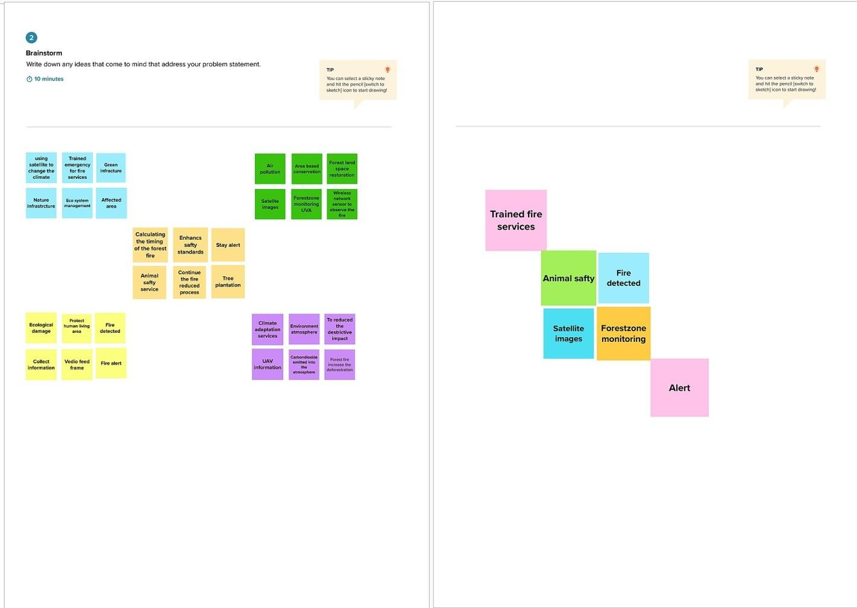

# Step-3: Idea Prioritization

